Village of Monroeville
PRST ST
U.S. POSTAGE PAID
NORWALK, OH
PERMIT NO 104
21 N. Main St.
PO Box 156
Monroeville, OH 44847

ADDRESS SERVICE REQUESTED

Home Sweet Village
....The Village Flea 2022....
Ya’ll! This year’s theme sure does have a special place in our hearts.
We wanted to capture all the warm & fuzzies that our sweet little town brings, as many folks both near and far forever call this place “home.” A rendition of our town’s crest, carved by Jim Herner who captured landmarks back to the horse and buggy days, is the perfect historical scenery so many of us hold dear. The grain mill next to the dam, covered bridge, steepled town hall just to name a few- all nostalgia we are proud of and memories generations will continue to carry throughout the years. It sure is “sweet” - we hope you feel so too.
And a little hint... this just *might* be the artwork we’ve been dreaming of for our town mural ! (More on this later)!
September 18th can’t get here soon enough and we are SO ready to celebrate with you at the 2022 VF! Details on shirts and other merchandise featuring this year’s theme coming soon!
Village Flea Committee

Hello Friends and Neighbors,

M
O C N
N O E
R M W
O M S
E U L
V N E
I I T
L T T
L Y E
E R

FALL 2022
I can hardly believe that we are approaching the final weeks of summer, leading into the final months of 2022! We have had a busy year, but it has been a year full of growth, pride and celebration. Earlier this year, I was honored to be asked to be the speaker at the Memorial Day ceremony by the American Legion. It was a beautiful day and I was honored to share a few of my thoughts with the crowd gathered there. Afterwards, I spoke with a gentleman from outside of our community who just happened to be there. He was extremely complimentary of the patriotism on display that day. He spoke of how impressed he was that our seemingly little Village showed up in a major way to remember and show honor to our fallen, including many generations getting involved in several ways. I proudly told him that's how things are done here!!!

Allow me to expound a little further on how “things” are here. Immediately following the ceremonies in Commons Park that day, our Monroeville Police Department, with the support of other local agencies and businesses, sponsored an afternoon of fishing for all ages at the annual Hooked on Fishing, Not on Drugs Event. At this event, Chief Lyons manned the grill as lunch was provided for all in attendance, along with toys for all of the youth and trophies for the winning fishermen. As long as I am talking about our police department, they once again offered a week-long Safety Town class for upcoming Kindergartners. As before, the department worked with other agencies, including our own Electric Department, to give back to the community and provide this service for our youngsters. That's just how things are done here!

In the very near future will be the official Open House of our Monroeville Municipal Complex. Because of Covid and the restrictions that surrounded it, we were unable to have such a celebration when we opened in September 2020. We are very proud of our building and the energy that continues to “build “downtown. Many years of planning, saving and fiscal responsibility got us to the place where this beautiful building could come to fruition WITHOUT having to go to the taxpayers for additional taxes, as well as come in under the projected budget. That's just how things are done here! (I am writing this at the end of August, so it will probably already have happened by the time this newsletter reaches your home. I will have more to say and show about this event in our next newsletter.)

Also coming soon will be the Village Flea, as it has moved to the fall this year. Thank you to all of those organizing this amazing event that highlights our wonderful Village and is a source of joy and fun for all who participate! Businesses and community people alike are responsible for this much-anticipated event! That's just how things are done here!

An official Monroeville welcome is in order for our newest businesses in the Village since my last writing. The Village Barn has recently completed their renovations and build to offer a beautiful venue within village limits. Also, Simply Monroe and Betsey's Boutique Shop have both opened on Main, with continued excitement brewing as additional businesses are set to officially open later this year. Stay tuned!!! I would also like to highlight Fireland's Federal Credit Union as they have been in Monroeville for 10 years and held a celebration earlier in the year. Well done!! Shortly after the upcoming new year, Marcia Adelman and the Beauty Vault will have served our Village for 50 years!!!! Congratulations!!! Are there any other businesses or organizations celebrating milestones this year? Reach out and let me know. I would love to hear about them and let your good work be known! Dedicated businesses that enrich our community is how things are done here!

As you will read in this newsletter, there is a great deal going on in the Village. You can also stay current with all Village news by visiting our new and improved website at monroevilleohio.com. Have you checked it out lately? Be sure to reach out to YOUR Village Council to share your comments, questions or concerns. Council members Craig Franklin, Joe Galea, Chris Raftery, Sue Rogers, Bob Whitacre, and Sam Wiley continue to work with Village administration as they contemplate and decide on the important issues to our Village.

I challenge each of us to strive to be the good that others need in their life. This way, we continue to build our reputation of Monroeville being the “Little Village with a Gigantic Heart!” After all, that's just how things are done here! I am proud of everything that the Village has accomplished and we will continue to serve our citizens to the absolute best of our abilities!

Yours in Service, Mayor Melissa Fries-Seip
Hooked on Fishing

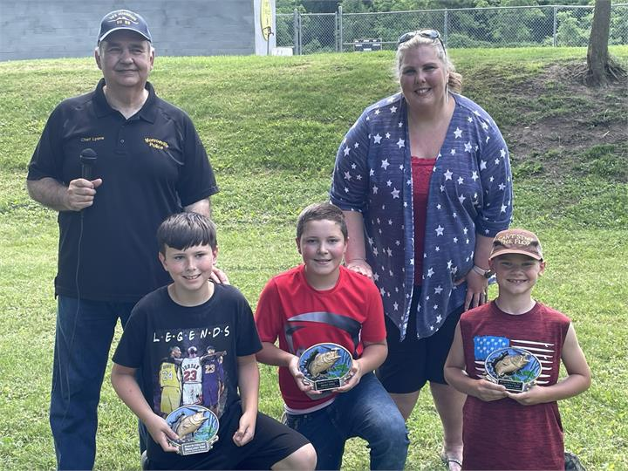
Hooked on Fishing was back this year! Approximately 120 people attended the event with 42 participants. A great time was had by all.

A special thanks goes out to all of the volunteers and businesses that donated their time and resources: The Twenty-First Century Foundation, Myers Rental Service, Dollar General, Firelands Credit Union, Bait Brothers, Nobil’s Sports & Trophy, Armour Eckrich Meats, New Horizons Baking Company, 7-Eleven of Monroeville, Frito-Lay, Rural King, and Fair Publishing. We couldn’t have done it without your support.

Pictured are Chief Lyons and Mayor Fries-Seip. Brad Hay received an award for largest fish (21 ¾ inches); Carter Carroll smallest fish (4 inches); and Austin Williamson most fish caught (16). Congratulations to everyone!

Safety Town

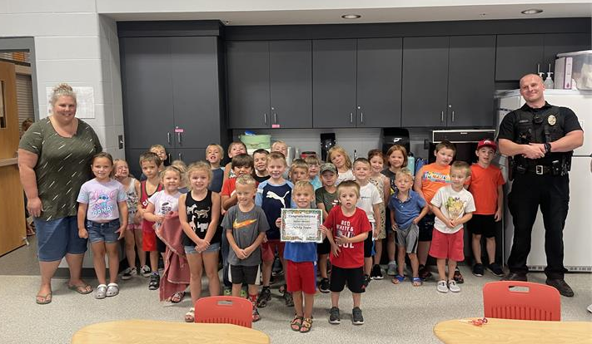
This year 28 children participated in our 2022 Safety Town. They observed and participated in presentations by the Monroeville Police Department; Huron River Joint Fire District; the Village of Monroeville Electric Department; Firelands Electric; North Central EMS, and Firelands Red Cross. A big thank you goes out to the Monroeville Public Schools for allowing us to use the MAC center and the cafeteria for our banquet of Pean’s Pizza! Pictured are the 2022 Safety Town graduates along with Officer Jordan Hanuscin and Mayor Fries-Seip.

Finally, I would like to thank those who volunteered their time. We couldn’t have pulled it off without them. Thank you, Mayor Fries-Seip, Heather Alicea, Mrs. Hanuscin, Mrs. Kimball, Chandler Kimball, Makenna, and Mattie.
Chief Lyons and Staff

Huron River Joint Fire District Awarded FEMA Grant

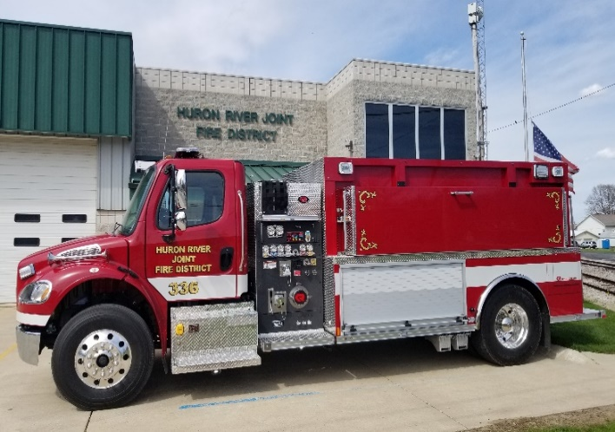
We are very excited to introduce our 2022 Rosenbauer Tanker that arrived at the district in April of this year. This truck replaces a 1970 GMC tanker that had served the department for 50 years, but had gotten tired and parts for repairs were difficult, if not impossible, to find. This new truck was paid primarily through a grant from FEMA. The grant process started about 9 years ago by then Chief, Tom Beck. The grant was applied for each year since and was finally awarded in August of 2020. The Huron River Joint Fire District received $278,000 from the grant with our department responsible for 5% of that amount, with the remaining from FEMA, Assistance to Firefighters Grant. This truck should serve the Village and townships of the Huron River Joint Fire District for many years to come.
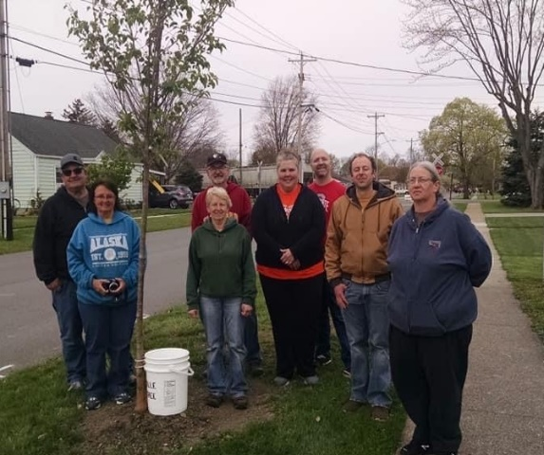
Did you know that Monroeville has been a Tree City for 16 years? To qualify we must have a tree program. This would include having a Shade Tree Commission, an Arbor Day celebration and purchasing trees for placement in the boulevard, with funding from the budget. We do an Arbor Day celebration every April and we do plant and remove trees in the boulevard. Our Shade Tree Commission consists of 5 members from the public and a liaison from the Village Council.

We are always looking for trees to plant in the boulevard, so if you would like us to consider your property for a planting, call the Village Office and they will forward your information to us. Our plantings are usually in the spring and the fall. We, also monitor trees to look for vulnerable trees that may be dropping limbs and/ or dying. If you would like us to look at a tree in your boulevard, please contact the office.
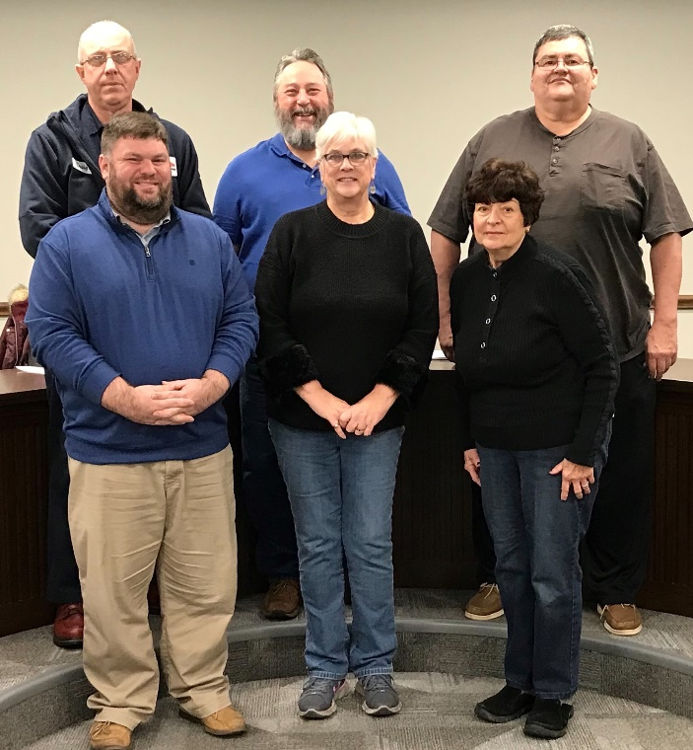

Do You Have A Favorite Area Food Truck?
Or Maybe You’re Thinking Of Starting A Business?

The Village now has an ordinance specially designed for food trucks to operate in the Village during a one-day festival, on any given weekday, or even for 40 days at a time! Food trucks that have been approved by the County Health Department can obtain a permit from the Village to set up shop during festivals (like the Village Flea) or for up to 40 days at a time in any given location. There is no charge for one-day festival approval and a $100 yearly fee for setting up an unlimited amount (subject to the 40 days at a time restriction). Food truck operators should stop by the Municipal Municipal Complex or call the office for more information and to obtain an application.

Joe Galea, Council Member

Council Members: Back row: Craig Franklin, Sam Wiley, Bob Whitacre
Front row: Joe Galea, Sue Rogers, Chris Raftery

HAVE YOU NOTICED?????

⇒The siding on the buildings at both Clark Park and Marsh Field have been replaced! Thanks to Helmstetter Home Improvements for their expertise in completing this task, which will prolong the integrity of the buildings for many more years.

⇒The railroad crossings at South Main Street, South Ridge Street and Monroe Street/Rt 547 have been improved with flashing lights and street lights. These safety enhancements improve the area lighting and visibility for the railroad crossings.

⇒Brown Street and Hollister Street from Rt 20 to Brown Street have been resurfaced, and they look terrific!

⇒Now that school has started, take special note of the 4-way stop at Chapel and Broad Streets. These signs were installed to help slow down traffic for the safety of the kids being dropped off or picked up at St. Joe’s, and further because of the lack of clear visibility for traffic coming from Chapel and Brown Streets onto Broad Street.
WATER & WASTEWATER:

VILLAGE OF MONROEVILLE
21 N. MAIN ST. PO BOX 156
MONROEVILLE, OH 44847

MELISSA FRIES-SEIP, MAYOR
mayor@monroevilleohio.com

BONNIE BECK, FISCAL OFFICER
419-465-2922 VOICE MAILBOX #2

THOMAS GRAY, VILLAGE ADMINISTRATOR
419-465-2922 VOICE MAILBOX #5

MONROEVILLE POLICE DEPARTMENT
NON-EMERGENCY
419-465-2474

ELECTRIC DEPARTMENT
419-465-4149

STREET DEPARTMENT
419-465-2800

WATER & WASTEWATER DEPARTMENT
419-465-4182

IN THE EVENT OF A POWER OUTAGE
OR LOSS OF WATER OUTSIDE OF
NORMAL BUSINESS HOURS,
PLEASE CALL THE POLICE DEPARTMENT
AT 419-465-2345.
THEY WILL CONTACT
THE ON CALL PERSON.

We would like to remind all sanitary sewer users not to dispose of any mercury containing items or fluids into the sewer. If you need help to get rid of such items, please call us at 419-465-4182 and we will help you dispose of it properly. There is a “Mercury in the Household” brochure on the Village’s website under the department’s dropdown tab under Wastewater, which contains a lot of information and ideas on where in your house you could find mercury. The employees of the Wastewater Dept., in order to comply with our permit, will be re-visiting the commercial customers to verify nothing mercury related has changed.

The Wastewater Dept. will continue to clean and inspect sanitary sewer mains this fall.

The Ohio EPA performed an inspection of our Wastewater Treatment Plant, reviewing records, log books, and operations. We received high marks, with no findings being reported.

The Water Department is nearing the completion of the meter replacement program, with only 6 left to replace. As a reminder meter reading generally occurs on the week of the 10th of every month.

The EPA is mandating public water systems to complete a lead service line inventory by October of 2024. To meet this mandate the Village needs to verify the service line material on both the Village and privately owned side (normally from meter or curb stop to the connection in the basement). In order to accomplish this, we will need to gain access to most basements. You can call the Water Dept. at 419-465-4182 to set up a day and time to have this done. The goal is to eliminate all lead from the drinking water service lines.

The Water Dept. personnel have addressed several water main leaks this year. They’ve performed top to bottom cleaning of the clarifiers, draining the clarifiers and flushing them before re-filling them, and they treated the reservoir to mitigate any potential alga bloom.

The following is a link to view the OEPA required Backflow informational brochure PWS-02-003 brochure.pdf(ohio.gov). This link is also available on the Village of Monroeville’s website under the Departments heading by clicking on Water.
If you ever have any questions concerning your water or wastewater, please call the Water Dept. (419) 465-4182.

This will be tentatively scheduled for the weeks of October 3rd & 10th. Water Dept. employees will begin flushing and valve exercising at approximately 8:30 am and stop around 3:00 pm daily. You may experience low flow and or cloudy/discolored water during this period. Please let your tap run and the condition should clear up relatively quickly.
Water & Wastewater Dept. Staff
PHOTO ENFORCEMENT

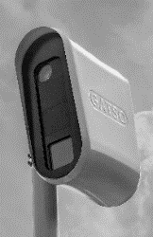
The Village of Monroeville has continued its agreement with Sensys Gatso to assist the Police Department in their photo enforcement efforts. Just to remind everyone, fixed cameras monitoring red light and speed violations are placed at the Monroe and Main Street intersection; east and westbound at the U.S. 20 and State Route 99 intersection and westbound traffic on U.S. 20 near the East Brooklyn Heights intersection. In addition, new cameras will be set up on State Route 547 near Underground Utilities Inc. and on North Street near Marsh Field. This is in addition to the mobile laser devices used by your officers. So please, obey the traffic laws!!

School has started so be sure to observe when the yellow flashing lights are in operation that signify a reduction in the speed limit to 20mph.

Ohio Collaborative

The Ohio Collaborative, a 12-person panel of law enforcement experts and community leaders from throughout the state, established state standards – for the first time in Ohio’s history – on August 28, 2015, for use of force including use of deadly force and agency employee recruitment and hiring that can help guide law enforcement agencies in Ohio. The Collaborative works closely with partners, including the community and law enforcement agencies, to implement the new standards. All law enforcement agencies are expected to meet or exceed these new standards as they develop policies and procedures to meet these new expectations.

Each year more standards are added to the Collaborative’s requirements. They include areas such as use of force; police pursuits; community relations; complaints against officers; and officer wellness. There were four sets of standards set by the Collaborative with the fifth one implemented recently. Your Police Department has met all four of the standards and are currently in the process of being in compliance with the fifth set of standards which involves response to mass demonstrations and officer wellness.

Please join us in welcoming Gerald Broekel III to our Police Department. Gerald was sworn in on April 27th and comes to us from the Republic Police Department, serving there for the past year as one of their part time officers. Gerald is a 2016 graduate of Vermilion High School and completed his Criminal Justice/Police Academy certification from EHOVE Career Center.
Chief Lyons

Good Bye Summer, Hello Fall!!

The Street Dept personnel had a busy summer. The lines on the tennis and basketball courts were repainted, and the nets were replaced. Street patching and downtown sidewalk repairs are ongoing. Branches were trimmed away from street and traffic signs, storm water basins were cleaned, and street sweeping was performed. As a reminder, Williams Street is now one-way, with the flow of traffic moving from Monroe Street to Rt 20.

After a great summer we are preparing for fall. With that being said, the final yard waste pick-up will be on Tuesday, October 25, 2022. With yard waste ending for the year, we’ll be going right into leaf pick up. Leaves will be vacuumed on an as-needed basis. Please have your leaves raked to the curbside by 7:00 AM, away from telephone poles and mail boxes in order to allow the vac truck to be most effective. Please do not rake leaves into the street. DO NOT rake any garbage, bottles, cans, sticks, limbs, or animal feces with the leaves. Anything other than leaves will be left for your disposal. The final leaf pick-up will be December 27, 2022, weather permitting.

As we approach the winter months, we will be checking over our plows and salt spreaders to make sure they’re ready for snow and ice removal. Please be cautious of employees clearing the uptown sidewalks and removing snow piles this winter, and please don’t crowd the snow plow. Remember, if you can’t see the side mirrors on the snow plow, the driver can’t see you! Vehicles should not be parked on the streets during a snow storm to ensure safe and efficient snow removal.

If you have any comments or concerns, please call 419-465-2800. Thank you! Street Dept. Staff

Daylight Savings Time
ends On November 6th
this Year.

Remember to turn your clocks back one hour and change the batteries in your smoke alarms and carbon monoxide detectors.

The Administrative Offices
will be closed on the following dates in observance of holidays…
Oct. 10th – Columbus Day Nov 11th – Veterans Day Nov 24th – Thanksgiving
Dec 26th – Christmas Observance Jan 2, 2023 – New Year’s Observance
Jan 17th – Martin Luther King Day Feb 21st – Presidents’ Day
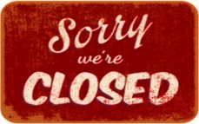
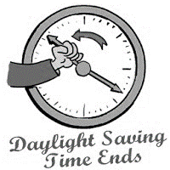

INCOME TAX AND ACTIVE WARRANTS

As the community is aware, the Village of Monroeville became a RITA municipality (Regional Income Tax Agency)
for collection of municipal taxes effective 1/1/2021. However, if you failed to file a Village of Monroeville income tax
return prior to 1/1/21 and/or if you accrued an unpaid balance prior to 1/1/21,
you may still have an outstanding income tax account with the Village of Monroeville.
Additionally, you may have an outstanding bench warrant with the Norwalk Municipal Court in regards to
your income tax account with the Village of Monroeville.
The Village Administrative Office has made several attempts to reach out to individuals with outstanding accounts. The Village
Office would like to assist individuals in addressing any outstanding balances and/or active warrants, in order to prevent
additional fees and interest from accruing. The Village Office will be posting a list of individuals with active bench warrants
through the Norwalk Municipal Court. If your name is on the list and/or if you know someone whose name is on the list, please
contact the Village of Monroeville Administrative Office at 419-465-2922. Bonnie Beck and Heather Alicea can assist you in
order to expedite resolving the outstanding account.
Again, SEVERAL ATTEMPTS have been made to contact these individuals prior to publication.
Bench warrants are a matter of public record.

The Village has an agreement with the American Municipal Power for their direction and instruction for Ohio’s OSHA program. The employees from the Electric, Streets/Parks, and Waste/Wastewater Departments meet on a monthly basis to train for such things as the proper use of hand and power tools, lifting and ergonomics, trenching, work zones, planning for emergencies, and safe vehicle operation.

Recently, the Fiscal Officer received the Village’s claims activity report from 1-1-2018 to 6-30-22 for their Ohio Bureau of Workers’ Compensation claims. In this 4 ½ year period of time, the Village had only 2 minor incidents. A BIG SHOUT OUT goes to the employees who regularly attend these OSHA training sessions for conscientiously applying what they learn to the functions of their every day jobs. Their safety mindedness has paid off in lower premiums for the Village, but most importantly it keeps them safe and injury free.

Along those same lines of safety, the Village recently stocked all of their department locations with new, updated ANSI and OSHA approved first aid kits. All of the departments also received new first aid kits and trauma kits for their trucks/cruisers. A first aid policy is in process, and personnel will be trained in the proper use of the first aid kits and the importance of calling 911 for certain incidents. The Administration is very mindful of the safety and care of their employees, and makes every effort to remain compliant with the safety regulations.
Administrative Office Staff
WHY IS CANDY HANDED OUT FOR TRICK-OR-TREATING?

For many, Halloween festivities center around candy. If you're wondering why you hand out candy on Halloween, the answer dates back to the 1950s. Before candy became the go-to treat in exchange for tricks, people passed out homemade cakes, popcorn balls, fruit, or coins. Candy manufacturers saw this as an opportunity to offer an economical alternative to these time-consuming baked goods: packaged candies. From candy corn to chocolate bars, Halloween candy is still a staple in modern All Hallows' Eve celebrations - just check out your grocery store aisles and you’ll see for yourself! And while you’re there, stock up on your candy supplies for this year, because Monroeville’s Trick-or-Treat event will start at 1:00pm on Sunday, October 30th with the sounding of the fire siren. The fire siren will sound again at 3:00pm to signal the end of Trick-or-Treating, but the fun continues as you take your youngsters to the high school to line up for the annual Halloween parade that starts at 3:30pm. The parade will end at the Huron River Joint Fire District station, where the high school band will entertain you with delightful music, and the kids can participate in the Halloween costume judging and collect even more treats and goodies!

We are continually upgrading our system, such as switching the old street lighting to new LED lighting and installing new electronic controls throughout the system. Both poles and lights were replaced along a portion of the Rt 20 corridor using underground wiring. We are also assisting St. Joe’s with their electrical upgrade and conversion to a 3-phase service. In July we did some heavy maintenance work at our Herbert substation, shutting down a portion of the system and addressing various hot spots and defective mechanisms. This was an all day task and we were quite successful in accomplishing our goals. Our staff is continually working on our SCADA system to further enhance our monitoring and control. SCADA stands for Supervisory Control and Data Acquisition, and it helps provide safer operations as information is gathered and processed with real-time data. For fun, we spoke at our annual Safety Town class about our electrical system.
U
P
G
R
A
D
I
N
G

&

M
O
N
I
T
O
R
I
N
G

So far this year we have 2 new residential customers in our system and one large service upgrade.

We will continue to do various equipment upgrades and make service wire repairs on our electrical system to make it more efficient and stable. Part of making our system more stable is doing tree trimming around our primary lines, which requires continual maintenance. We are still installing animal guards/protectors throughout the system to minimize animal contacts that result in outages.

As always please report any outages/problems to the Electric Dept.at 419-465-4149 or to the Administrative Office at 419-465-2922 as soon as possible (after hours please call the Police Dept so they can contact the on-call employee). Remember to NEVER touch any electric lines that are on the ground or within your reach.
Electric Dept. Staff

P
R T
O H
J E
E
C V
T I
S L
L
T A
H G
R E
O
U
G
H
O
U
T

Columbia Gas is now underway with a line replacement project running from the pressure regulating station at Hamilton and River Road to the Trans Canada pipeline connection north of Washington Road. Part of the scope of work is the replacement of all service lines and the removal of inside gas meters on Horseshoe Drive and Kreider Lane. As of this writing, all of the Village underground and overhead facilities are being video-mapped prior to the start of actual construction. Miller Pipeline is the sub-contractor who will be performing the work.

The 2022 air-conditioning season got off to a “hot start” back in May. June 15th saw the highest demand for electric consumption power in the Village. This high demand day has not been surpassed and will probably be the annual peak usage day for the Village for calendar year 2022.

You probably have noticed the LED cross walk signs at Clark Park are missing. Both signs were damaged by hit and run vehicles. The Street Division is working to secure repair and replacement costs.

Lot sales and home construction continues on Eagle View Drive. It is nice to see this activity in an area that has been dormant for many years.

The Village was pleased to be a part of the HVAC upgrade at St. Joe’s School. A new three-phase electric service and transformer have been installed to support the operation of the new units. This project was a great collaboration between the School and Village.

Monroeville Local Schools and the Village are engaged in dialog to finally bring to fruition a new Monroeville Local Schools track and field area on North Ridge Street. An initial land survey is underway with plans and specifications then being presented to the Planning Commission for review.

Council continues to address funding possibilities for the reconstruction of Hamilton Street between Milan Avenue and Broad Street.

In the downtown, design and engineering are moving forward for a street scape / sidewalk replacement project. In addition, the Village has a design and engineering study underway to determine if it is feasible to turn the former Commercial House property into a parking area.

Please enjoy the Village Flea and all of the fun activities on September 18th!
Tom Gray, Village Administrator

